A Minor Project Report of

**YC_KICKS**

Submitted in partial fulfilment of the requirements for the degree of Bachelor of Engineering in Software Engineering at Pokhara University

***By***

**SUSHANT RAHAPAL**

**SUSANT BASNET**

**BIGYAN BISTA**



**Department of Research and Development**

**GANDAKI COLLEGE OF ENGINEERING AND SCIENCE**

Lamachaur, Kaski, Nepal

**(November, 2020)**

A Minor Project Proposal of

**YC KICKS**

Submitted in partial fulfilment of the requirements for the degree of Bachelor of Engineering in Software Engineering at Pokhara University

***By***

**SUSHANT RAHAPAL**

**SUSANT BASNET**

**BIGYAN BISTA**

***Supervisor***

**ER. ASHIM KHADKA**



**Department of Research and Development**

**GANDAKI COLLEGE OF ENGINEERING AND SCIENCE**

Lamachaur, Kaski, Nepal

**(November, 2020)**

**BONAFIDE CERTIFICATE**

This is to certify that this project titled **YC_KICKS** in partial fulfilment of the requirements for the degree of BACHELOR OF ENGINEERING IN SOFTWARE ENGINEERING is a bona fide work of **Sushant Rahapal, Susant Basnet, Bigyan Bista** under the supervision of **Er.Ashim Khadka**. It is further certified that this work doesn’t form part of any other project work on the basis of which a degree or award was conferred on any earlier occasion on this by any other candidate.

**Date of Evaluation**: November 11, 2021

|  |  |
| --- | --- |
| ……………………………...…  Er. Rajendra Bahadur Thapa  Supervisor | ……………………………...…  Er. Sujan Tamrakar  Project Head |
| ……………………………...…  Ashok Raj Parajuli  Vice Principal | ……………………………...…  Er. Shiva Ram Dam  External Evaluator |

# ABSTRACT

**YC Kicks** is a website for e-commerce purpose. In this website, different brands of shoes are available with high durability and quality. Customers who visits and wants to buy need to log in. They will get notified after they register an order from this website and the business workers will deliver their product as soon as possible by cash on delivery method. When the users visit this business page, various details about different brands of shoes is displayed. The business owners can update the product availability. The buying and delivering process is made as fast as possible. This business runs smoothly on certain cities right now (**Kathmandu** and **Pokhara**). The branch is expected to expand after few years for quick delivery.

**TABLE OF CONTENTS**

Chapter 1 INTRODUCTION 1

1.1 BACKGROUND 1

1.2 PROBLEM STATEMENT 1

1.3 OBJECTIVES 1

1.4 IMPLICATION 2

Chapter 2 LITERATURE REVIEW 3

Chapter 3 TOOLS AND METHODOLOGY 4

3.1 REQUIRED TOOLS 4

3.2 METHODOLOGY 5

3.2.1 USE CASE DIAGRAM 5

3.2.2 SYSTEM SEQUENCE DIAGRAM 7

3.2.3 ENTITY RELATIONSHIP DIAGRAM 8

Chapter 4 TEST CASES 9

4.1 SOFTWARE TESTING 9

4.2 TEST OBJECTIVES 9

4.3 TEST RESULTS 10

Chapter 5 RESULTS AND DISCUSSIONS 12

5.1 LIMITATIONS 12

5.2 FUTURE IMPROVEMENTS 12

Chapter 6 CONCLUSION 13

BIBLIOGRAPHY 14

APPENDICES 15

**List of Figures**

Figure 3.2.1: Use Case Diagram (UCD) of YC_KICKS 5

Figure 3.2.2: System Sequence Diagram (SSD) of Customer and Admin 7

Figure 3.2.3: Entity Relationship Diagram (ERD) of YC_KICKS 8

**List of Tables**

Table 4.1: Test Cases................................................................................10

**Chapter 1**

# INTRODUCTION

## 1.1 BACKGROUND

Due to the increasing number of local businesses in Nepal, it is very difficult to find the right ones that we need. Some may use false advertisement; some may not live up to their promise and some even straight up use deception. There is no trust-able tool for us to tackle this problem. One way is to go to each and every of these local businesses and test the services they offer but it is impractical and ineffective. More and more people are gaining access to mobile devices and their use time is increasing at a steady rate. So, taking advantage of such events, this project helps people choose the right product without any confusion.

## 1.2 PROBLEM STATEMENT

In this era, almost everything occurs digitally. As a developing country, it opens up a lot of opportunities for people to do something. Among them, e-commerce is the most popular one. In our country, we hardly see websites and shops that focus on different brands of shoes. So people need to order from international market which is costly and time consuming method. To overcome this problem, our project helps drastically.

## 1.3 OBJECTIVES

**YC Kicks** is an online website that provides various brands of high quality shoes. This project will fulfill the following goals:-

* To provide high quality and affordable shoes.
* To save the valuable time of people.

## 1.4 IMPLICATION

**YC Kicks** will help people to find best shoe products in our country with different brands available to buy. People will easily find their shoes they desire to buy from a long time for sure. It will help to save valuable time and economy of customers. Customers do not need to visit any store as we provide cash on delivery feature for every product.

**Chapter 2**

# LITERATURE REVIEW

As we all know, internet and e-commerce are entirely committed towards every developed country. But we think it can be accomplished and can make a remarkable benefit to developing countries also if an ideal business purpose can be made. So, we conducted a literature review of those systems and came up with ideas to overcome the shortcomings.

* KICKZ :

Kickz is an online-shop for premium sneakers and urban fashion. They provide customers with the newest models of the most popular brands. Customers will also find many shoes on sale and street wear. With its deep knowledge and experience in the street and basketball wear market.. (Kickz, 1993)

* ZAPPOS :

Zappos, initiated from 2000s, began as a small online retailer that only sold shoes. Today, they still sell shoes – as well as clothing, handbags and accessories. Their aim is to inspire the world by showing it’s possible to simultaneously deliver happiness to customers, employees, vendors, shareholders, and the community in a long-term, sustainable way. (Zappos, 2009)

# Chapter 3 TOOLS AND METHODOLOGY

## 3.1 REQUIRED TOOLS

The following tools was used for the development of the website:

* Programming languages to be used
  + - HTML
    - CSS
* Scripting languages to be used
  + - JavaScript
    - PHP
* Database
  + - MySQL
* For making diagrams
  + - Diagrams.net
* For making Gantt chart
  + - MS Excel
* For making wireframe
  + - Adobe XD

## 3.2 METHODOLOGY

### 3.2.1 USE CASE DIAGRAM

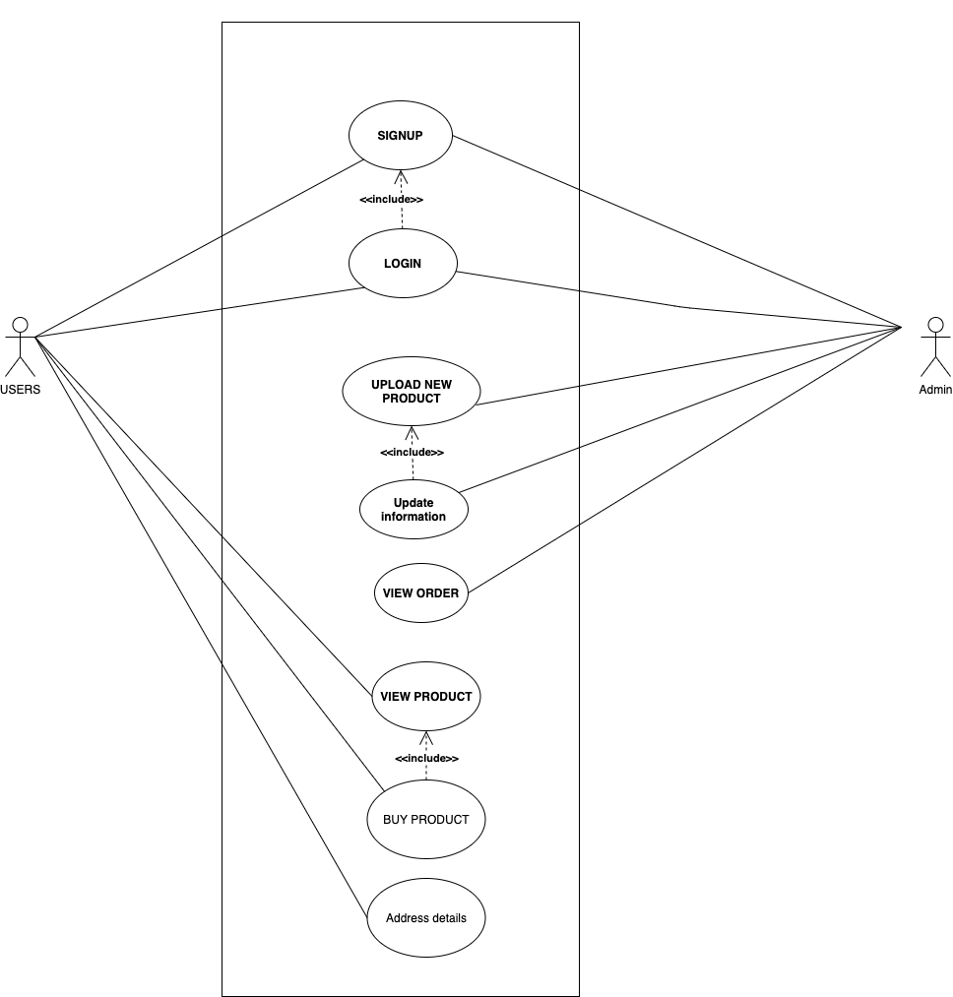

**Figure 3.2.1: Use Case Diagram (UCD) of YC_KICKS**

**Use Case UC1: LOGIN**

**Primary Actor:** USER

**Precondition:** Account must be created.

**Postcondition:** User can login and access the website.

**Use Case UC2: UPDATE INFORMATION**

**Primary Actor:** ADMIN

**Precondition:** Admin can upload information,edit it and delete it.

**Postcondition:** Admin can view the order lists of the respective product.

### 3.2.2 SYSTEM SEQUENCE DIAGRAM Figure 3.2.2: System Sequence Diagram (SSD) of Customer and Admin

### 

### 3.2.3 ENTITY RELATIONSHIP DIAGRAM

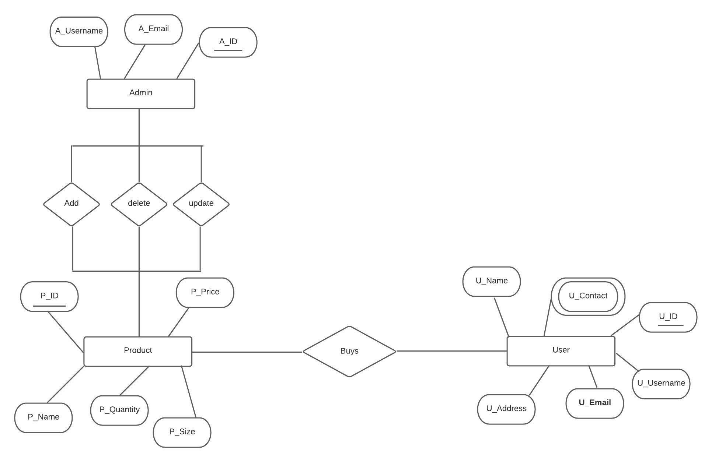

**Figure 3.2.3: Entity Relationship Diagram (ERD) of YC_KICKS**

# Chapter 4 TEST CASES

## 4.1 SOFTWARE TESTING

Software testing is a process, to evaluate the functionality of a software application with an intent to find whether the developed software met the specified requirements or not. It also identifies the defects to ensure that the product is defect-free in order to produce a quality product.

## 4.2 TEST OBJECTIVES

The main objectives of testing YC_KICKS were to:

* Check whether the web application is as per the requirements or not.
* Ensure defects get a fix from the developers before deployment.
* Gain confidence in the level of quality of the system.

## 4.3 TEST RESULTS

|  |  |  |  |  |
| --- | --- | --- | --- | --- |
| S.N. | TEST CASES | EXPECTED | OBSERVED | RESULT |
| 1. | Authentication for admin | A specific email with its respective password should be used | Only specific emails with its respective correct password are logged in | Ok |
| 2. | Upload products | -Products can be uploaded .  -Uploaded product can be manipulate | -Products uploaded by the admin are displayed and can be viewed by the users.  ………  -Every product displayed can be edit, update and delete. | Ok |
| 3. | Purchase of Products | - Products selected by the users can be displayed in the admin panel with the details of customers. | - Products which are selected by the users are displayed with the details. | Ok |

**Table 4.1: Test Cases**

# Chapter 5 RESULTS AND DISCUSSIONS

## Our project YC_KICKS helped us to learn in detail about the development of web application. It provided us the opportunity to get expertise in various web development languages. Our product can be used in the real-world for online shopping. This project was completed within the estimated time and with the coordination of team members

## 5.1 LIMITATIONS

This website was designed in focus for making possible to buy trendy shoe in Nepal as it’s hard to find trendy shoe in market. But there are some limitations. They are listed below:

* Internet access is required.
* Technical persons needed to manage the system.
* Digital devices are required for accessing the website and developing quality content.

## 5.2 FUTURE IMPROVEMENTS

Some of the improvements that can be implemented in the future are as follows:

* Optimization of the system.
* Addition of new features and functionalities.

# Chapter 6 CONCLUSION

YC_KICKS is a website for buying high copy trendy and fancy shoes easily in Nepal. This website provides a platform for users to buy shoes that are famous in the world and the shoes mostly worn by celebrities, at low cost. Admin can manage data of products. Users as a guest can view products but they must sign up to buy shoes. Overall, YC_KICKS is a website that helps people to buy a trendy shoes and also maintain sneaker culture in Nepal.

# BIBLIOGRAPHY

(1993). Retrieved from Kickz: https://www.kickz.com/de/

(2009). Retrieved from Zappos: https://www.zappos.com/about/?utm_campaign=zappos&utm_medium=zappos-home&utm_source=footer&utm_content=text

# 

**APPENDICES I**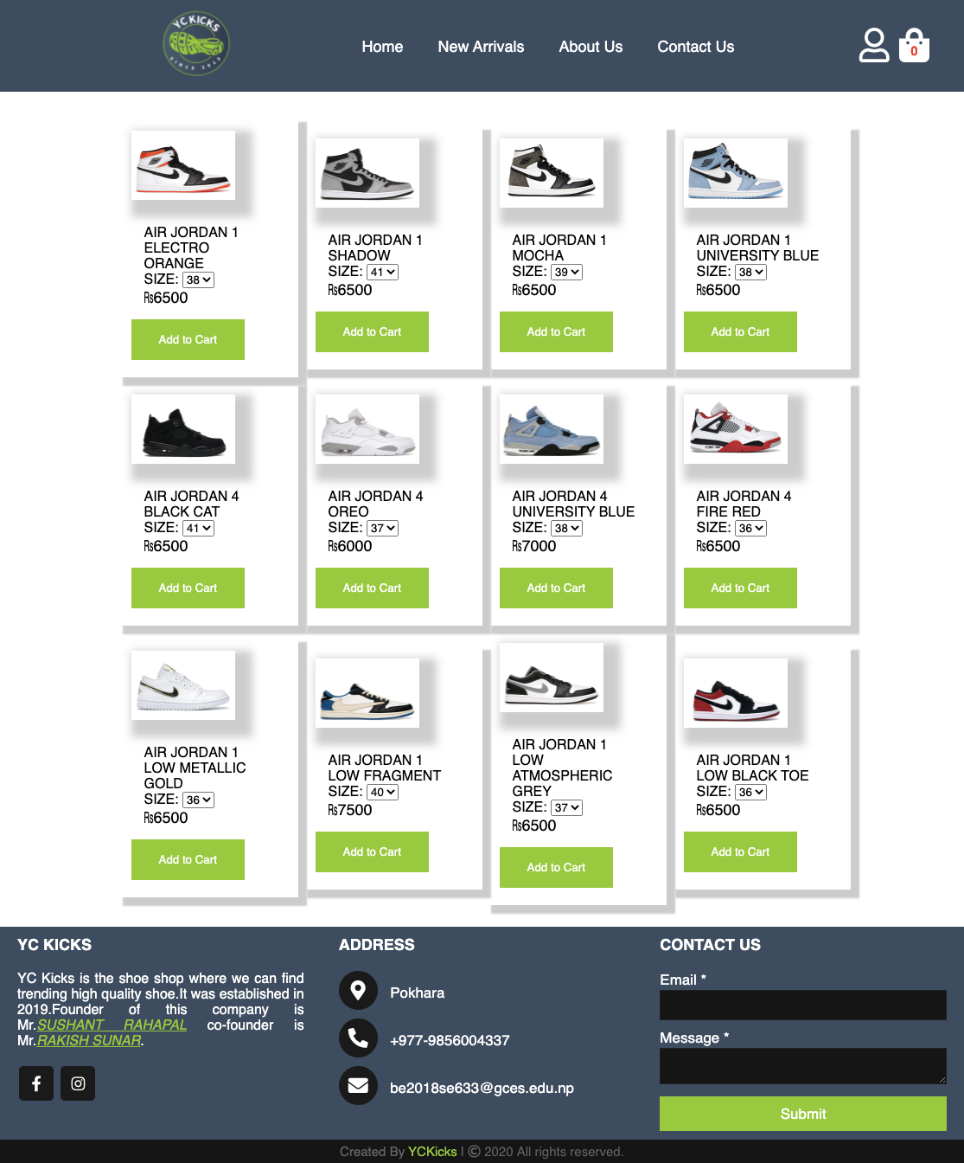

**Figure I.1:Landing Page**

# 

**Figure I.2:Login Page**

# 

**Figure I.3:Signup Page**

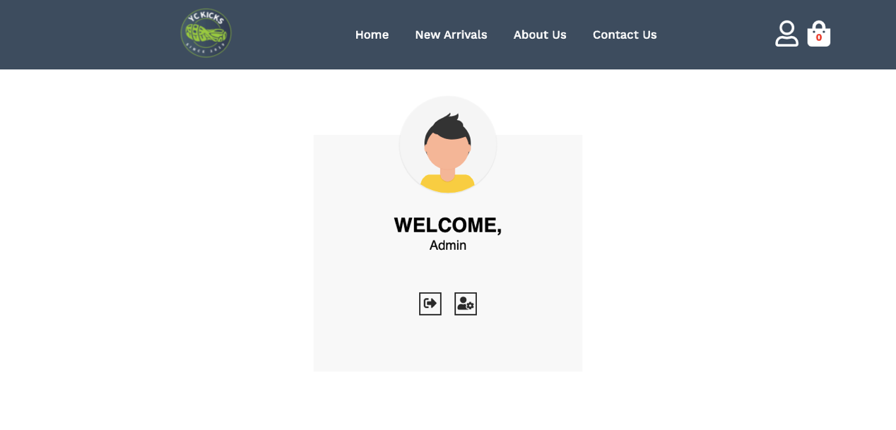

**Figure I.4:Admin loggedin Page**

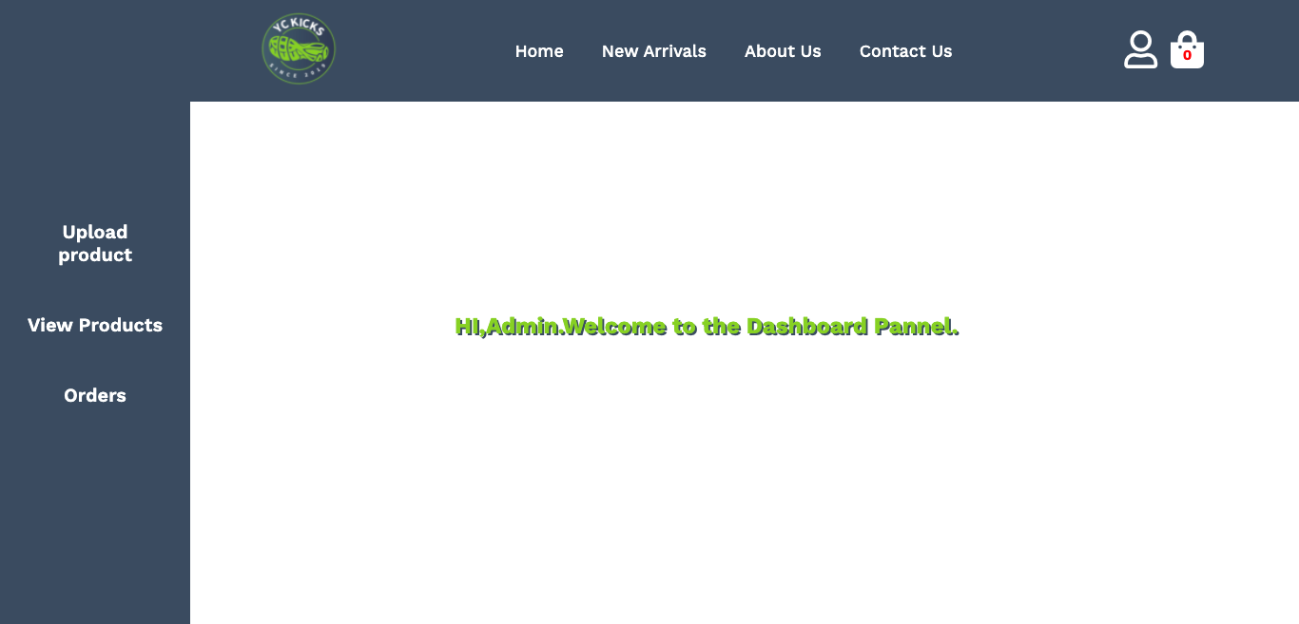

**Figure I.5:Admin Dashboard Pannel Page**

### 

**Figure I.6:Upload product Page in Dashboard Pannel**

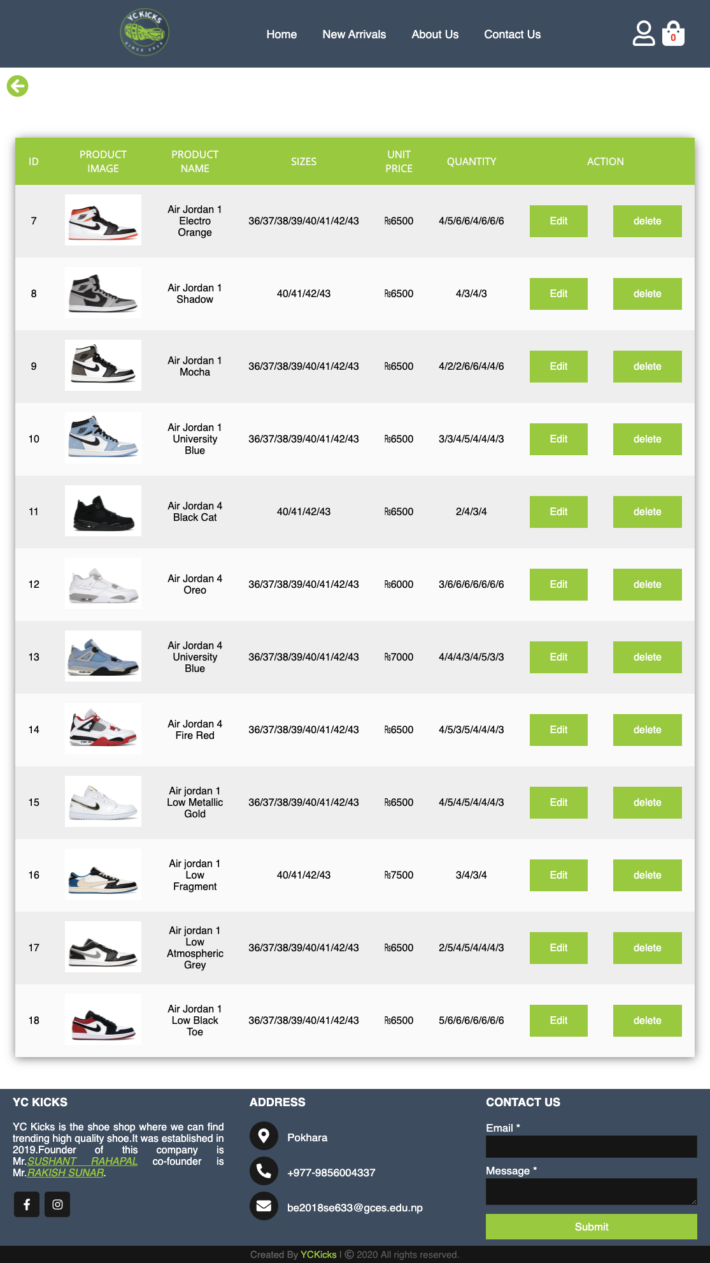

**Figure I.7:Uploaded product in Dashboard Pannel Page**

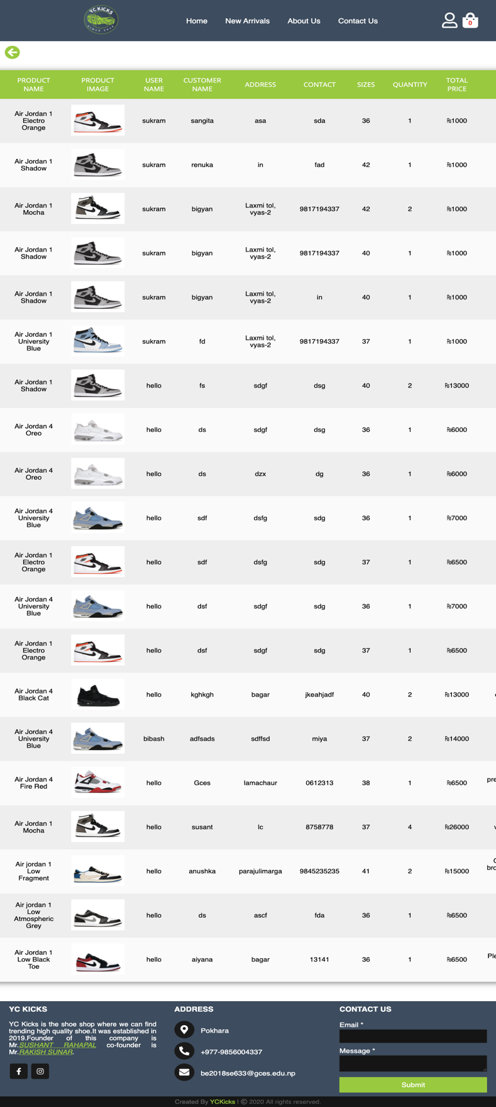

**Figure I.8:Orders in Dashboard Pannel page**

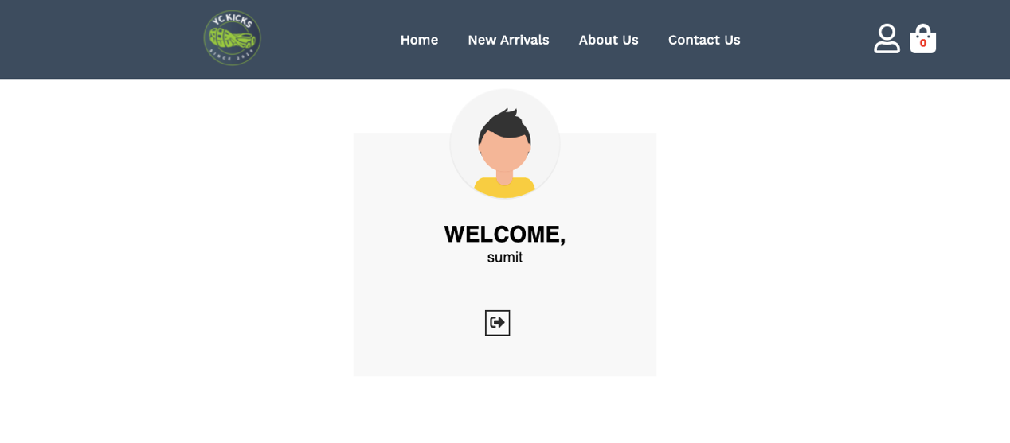

**Figure I.9:User Logged in Page**

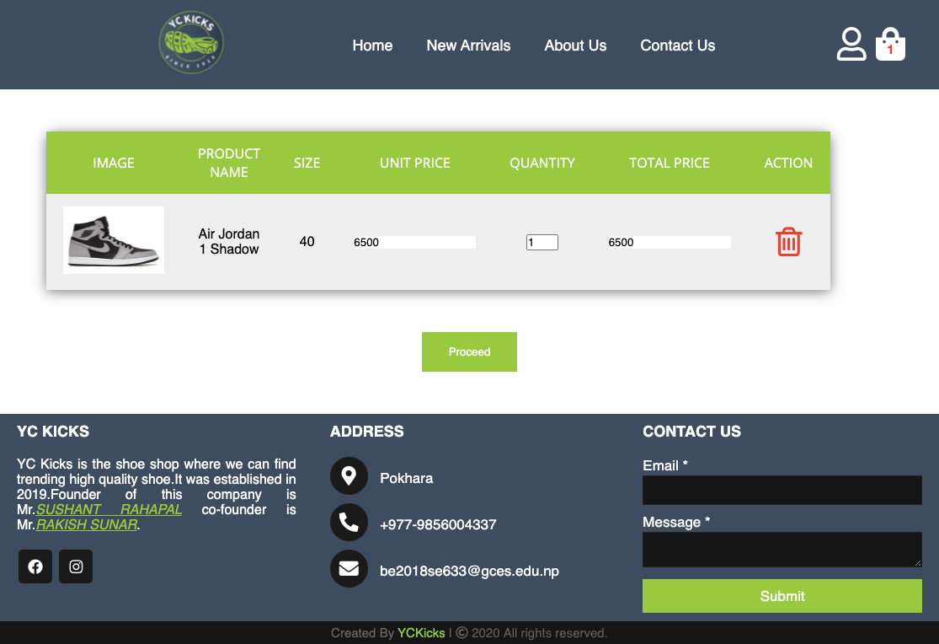

**Figure I.10:Add to Cart Page**

### 

**Figure I.11:Checkout Page**

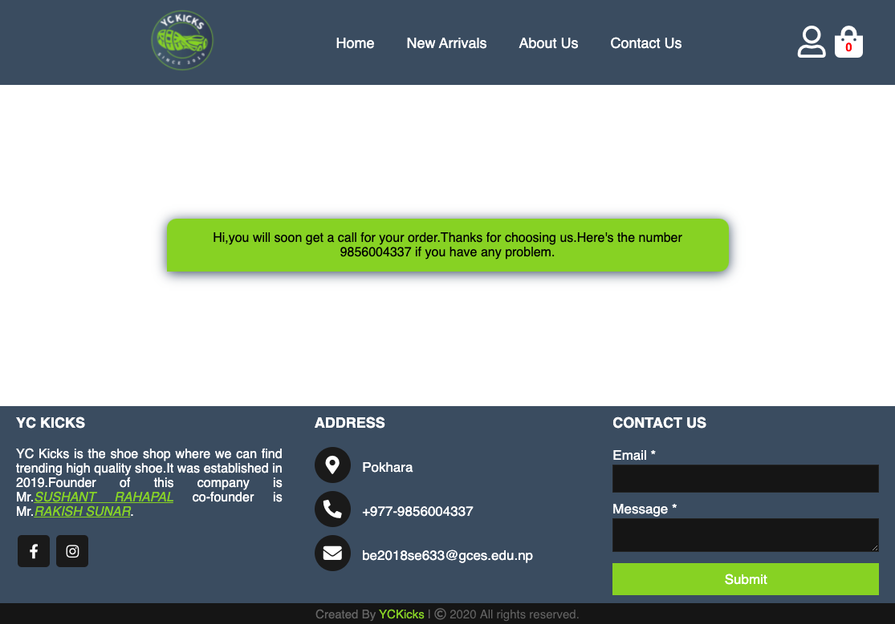

**Figure I.12: Purchased Suceess Message Page**